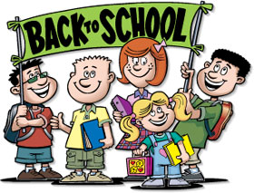
Star of the Sea Catholic School
15024 24 Ave. Surrey, BC
604-531-6316

Dear Grade 2A Parents and Students,

Welcome back! I hope you had a relaxing summer and that you are ready to begin the new school year with enthusiasm. I am thrilled to be your child’s teacher and I am looking forward to creating a memorable year together!!

All school supplies will be labeled at school this year, and any extras will be stored. If you are missing any necessary items, a note will be sent home by the end of the week.

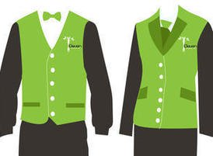
Labeling
nown Author is licensed under CC BY
If you have not done so already, please label each uniform piece, including gym strip, runners and dress shoes. It is also a great idea to label water bottles, Tupperware, backpacks, etc. This will help classroom management a lot.

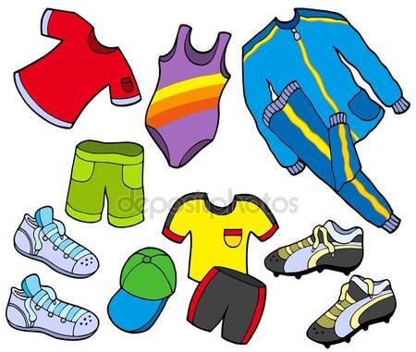
Gym/P.E.

Please make sure you have all the proper P.E. items (shirt, shorts, sweatpants, sweatshirt, gym bag, shoes). Gym bags must be sent to school on Monday and will come home Fridays for washing.

Family Needs
Please let me know as soon as possible if your family has any unique needs that I should be aware of. This includes allergies/medical concerns you may have and any regular special pickup arrangements, other than what is listed at the office.

I look forward to meeting all of you at Meet the Teacher night next week.

Mrs. Barb Niwa
bniwa@starofthesea.ca

